Task No 01:

Create a PowerPoint presentation with Title “My Software Product”, include the transitions, animations, images and the following headings should be included in the slides:

* 1. Problem statement
  2. Existing system
  3. Features
  4. Hardware Requirements/ Software Requirements
  5. Drawbacks

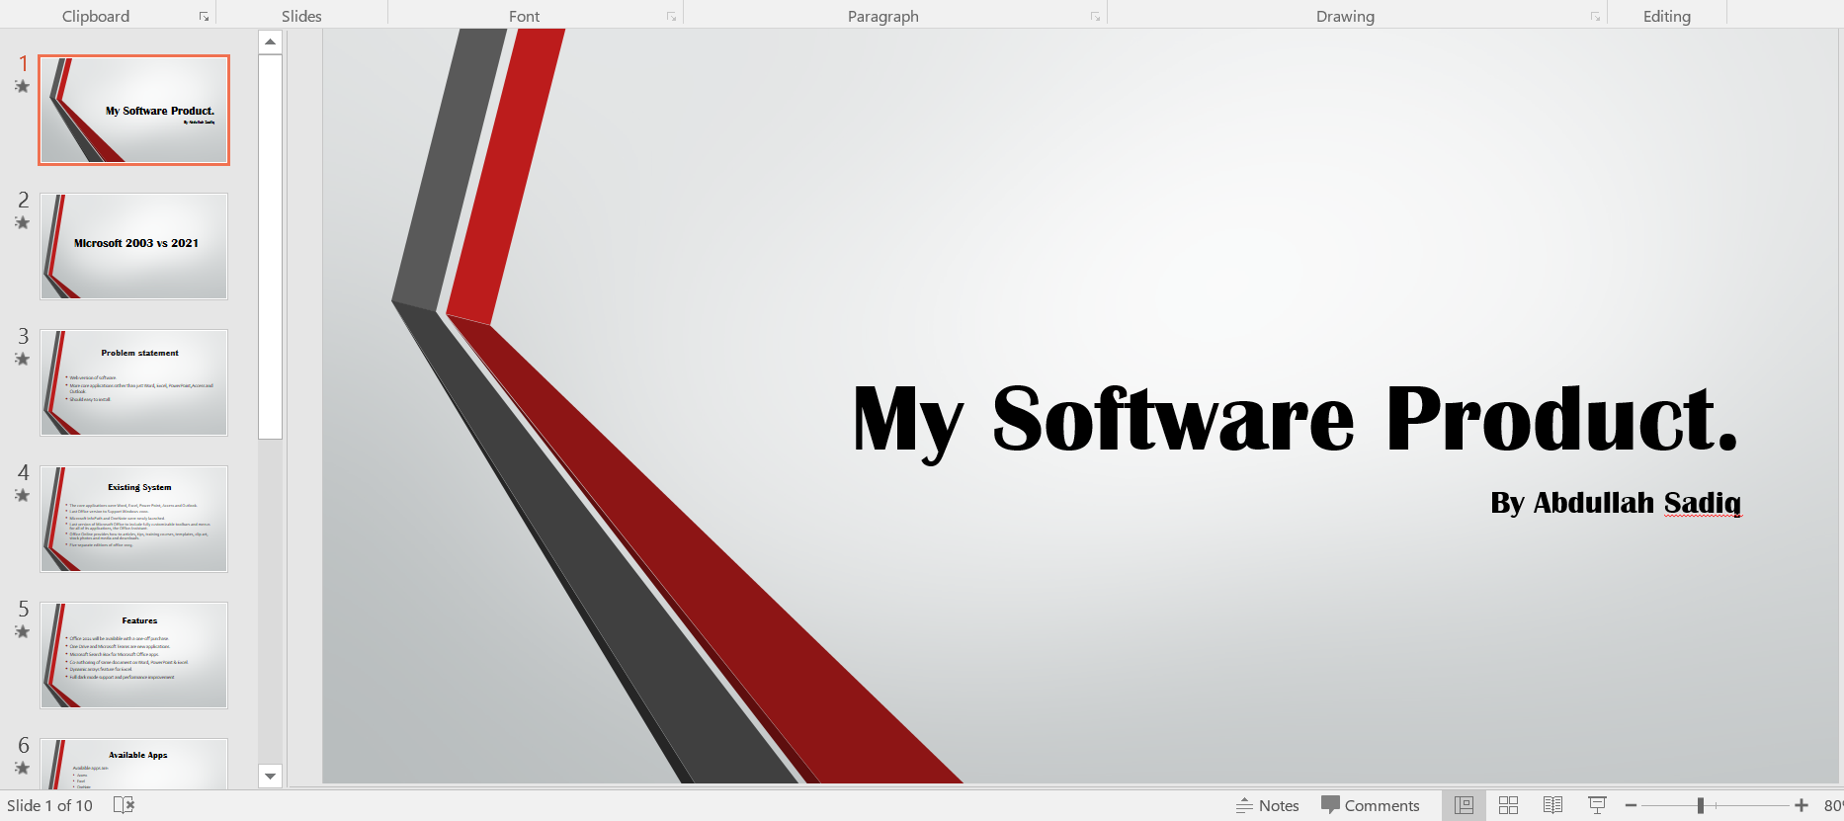





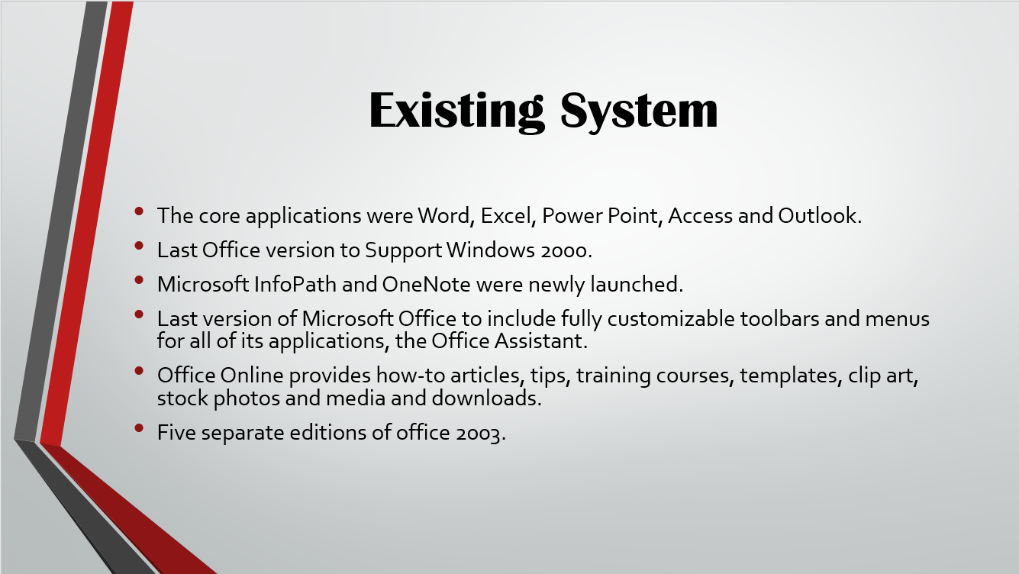

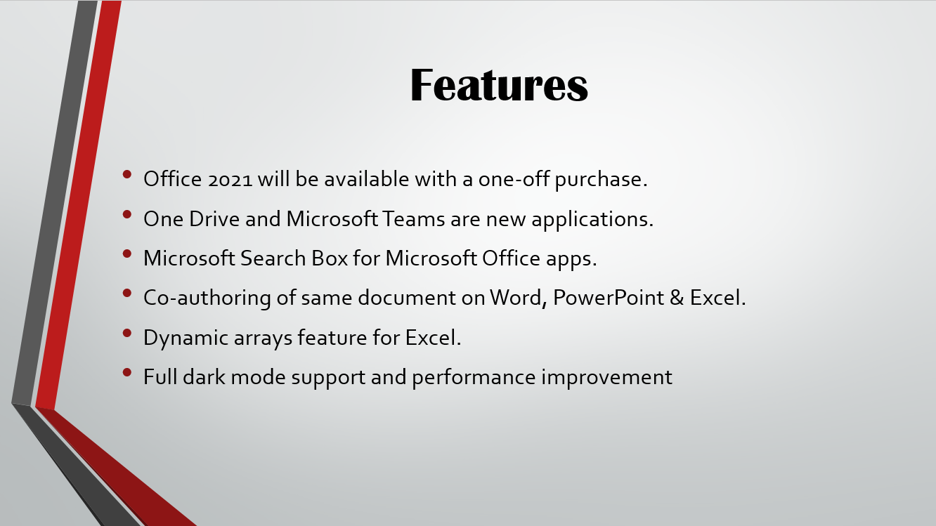

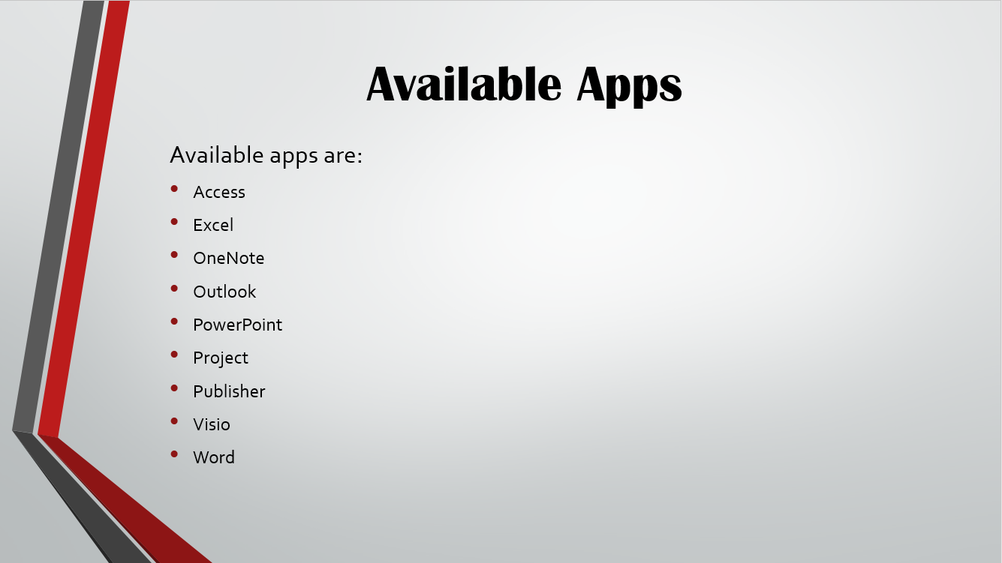

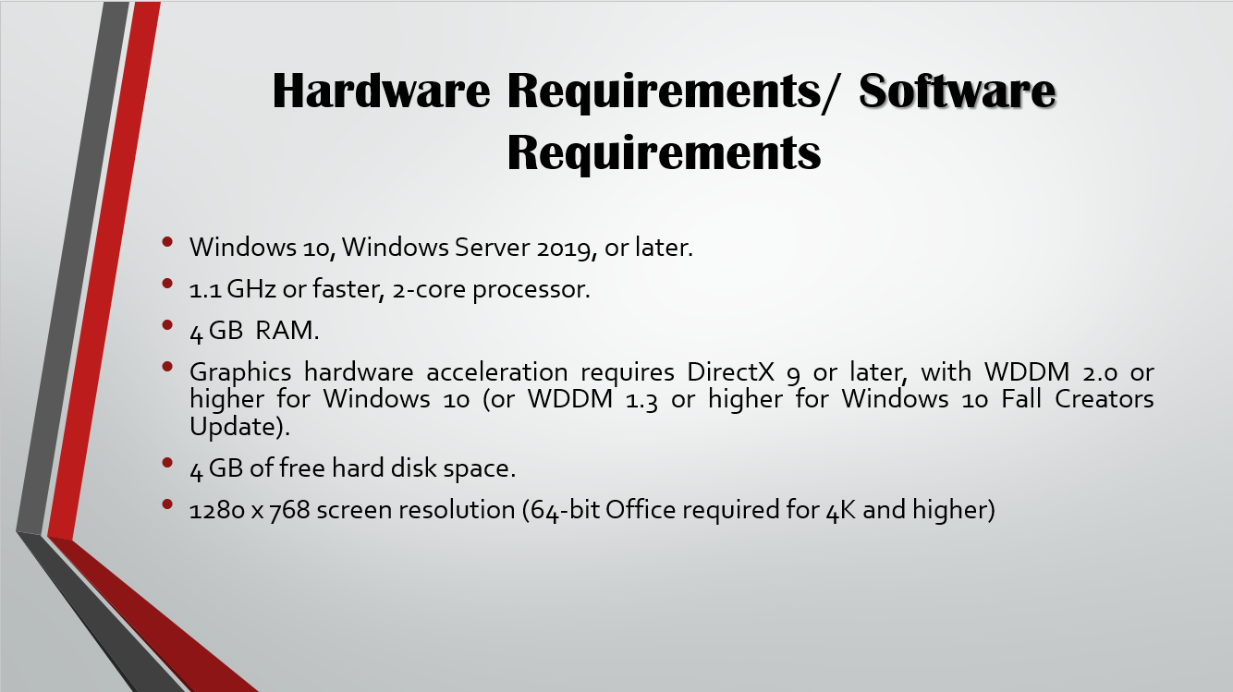

Task No 02: Create a PowerPoint presentation with Title “Dives Visualization”, and add the following features:

* On **slide 2** add a **column chart that shows the following information:**

|  |  |
| --- | --- |
| **Location** | **Number of Dives**  **this Year** |
| Red Sea | 1780 |
| Caribbean | 3280 |
| Thailand | 3387 |
| Hawaii | 2472 |
| Belize | 1398 |

* Make sure that the chart also includes the following:
  + The heading **‘Best Places to Dive’.**
  + Horizontal axis label of **‘Location’**. Vertical axis label of **‘Number of Dives this Year’**.
  + The **legend should be removed.**
* Position the chart in the space below the text **‘This chart shows the best places to dive:’**.

